MY FIRST SINGER 29K13

A restoration article by Ken Jerrems.
Jan 2007.

IN THE BEGINNING

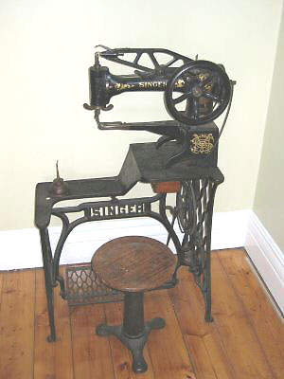
After searching for several months, my latest acquisition finally turned up on eBay.

I could hardly believe my eyes, not only did the machine appear to be in reasonable condition, it was located less than 20kms from me. All other machines I’d looked at were overseas.
One the downside, the AUD $800 Buy-it-Now price was far more than I anticipated, and it was a fairly early model, built back in the days of the horse and cart, 1920.
The auction ran for a week, and in my favour, no one placed a bid. After contacting the Seller, and after much haggling, I committed to buying it for AUD $750, still more than I could afford. To justify the purchase, I kept reminding myself, it’s only money, and besides, several other Singer machines, purchased in the hope of sewing leather, and wouldn’t, could be put back on eBay along with a myriad of “must have, don’t need” items.
Actual Singer 29K13 with Singer stool
The short drive to a North Melbourne warehouse, seemed to take forever.

Finally the roller door went up, and there it was, covered in dust.
After many questions, it was obvious the seller knew even less about the machine, than I did, I was on my own. Pretending to know more than I did, everything appeared to be intact, and we shook hands after handing over a bank roll big enough to choke a horse.
Separating the machine head from it’s treadle base, it was carefully loaded into the boot of my car with the aid of four burly blokes. The Singer stool was an optional extra I had to pass up, a pity really, because the two belonged together. At AUD $150 non negotiable, I couldn’t justify it.

I had a smile on my face, all the way home, until it was time to figure out how I was going to lift the machine out of the boot, on my own.

Donning my Superman outfit, I somehow managed to find the strength to lift and carry the machine inside, followed by the treadle base.

THE BIG CLEAN UP

With the machine moved again, to an outside table, a thorough clean and oil revealed it was in better condition than I first thought. A couple of thumb screws were missing, nothing important.
Once back inside, it didn’t take too long figuring out how to thread it up with much help from moderator’s and members via the Needlebar forum.

A HIDDEN BONUS

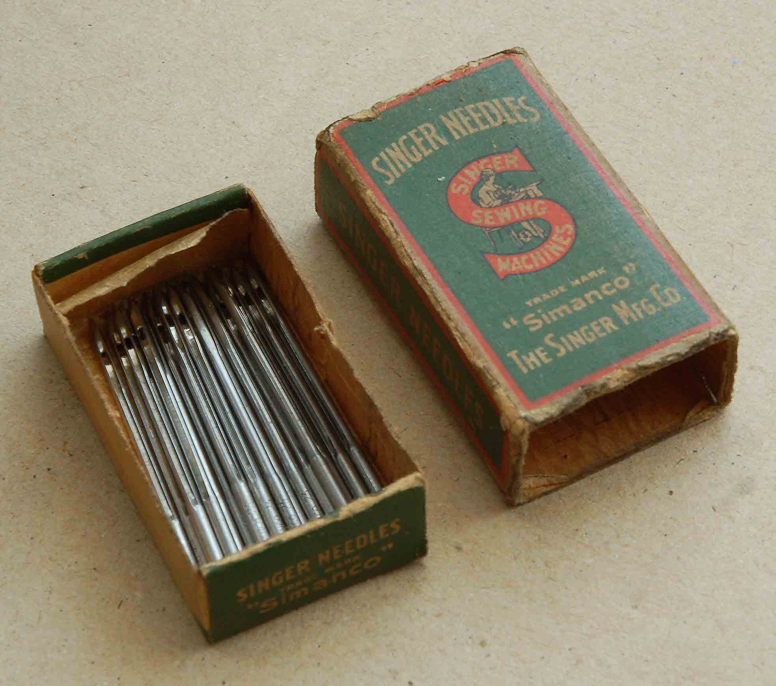
Inside the slide out wooden drawer was a bonus, half a box of genuine Singer leather point needles, new.
The green cardboard needle box has the genuine
Singer red S logo on the front.

To a collector, it’s probably worth a small fortune.
It’s not for sale along with the genuine Singer oil can.
Old box of Singer needles

ANOTHER PROBLEM

I could now sew two layers of 3mm leather together, but the distance between stitches was too close at 2.5mm. Ideally 3 to 4mm would be ideal. With the stitch regulator fully down, I was snookered. If I gently pushed the leather through, I could get the stitch length I wanted, so why wouldn’t the machine do this without help, it was time to investigate.
ALL OR NOTHING

It was time to carefully pull the machine apart, I couldn’t wait to find out exactly how this old marvel of ingenuity works.
The first step was to disconnect the flat spring steel bar across the rear of the machine, then the top arm from the needle bar by driving out the tapered pin. This was a challenge, it was locked in tight, but finally yielded without any damage using a pin punch, and a steel weight held up against the arm.

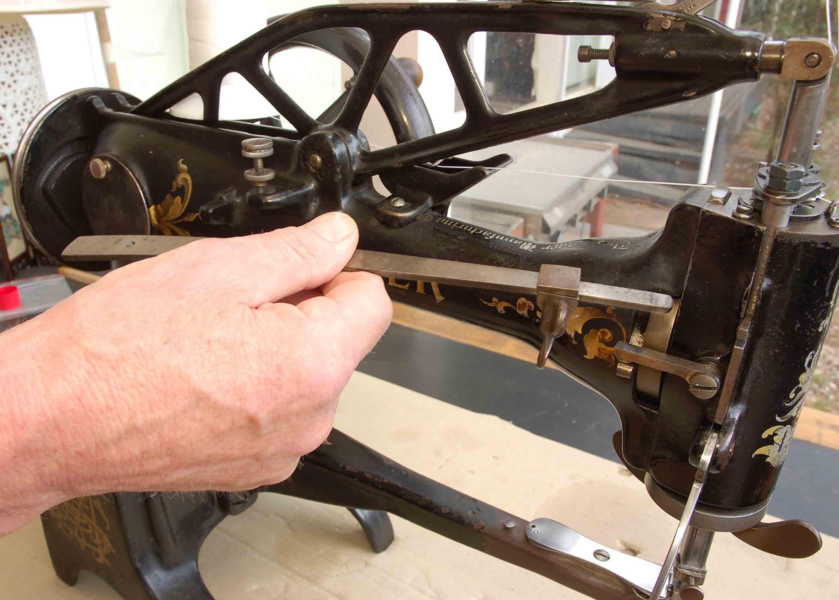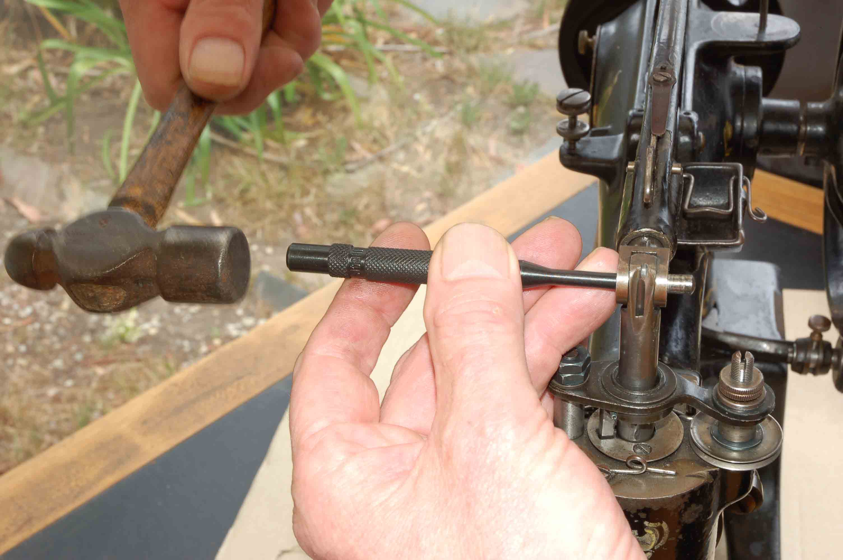
Removing the flat spring steel bar. Driving out the tapered pin.

By trial and error, I finally had the entire left hand end of the machine, in my hand after undoing four screws and disconnecting other bits and pieces.
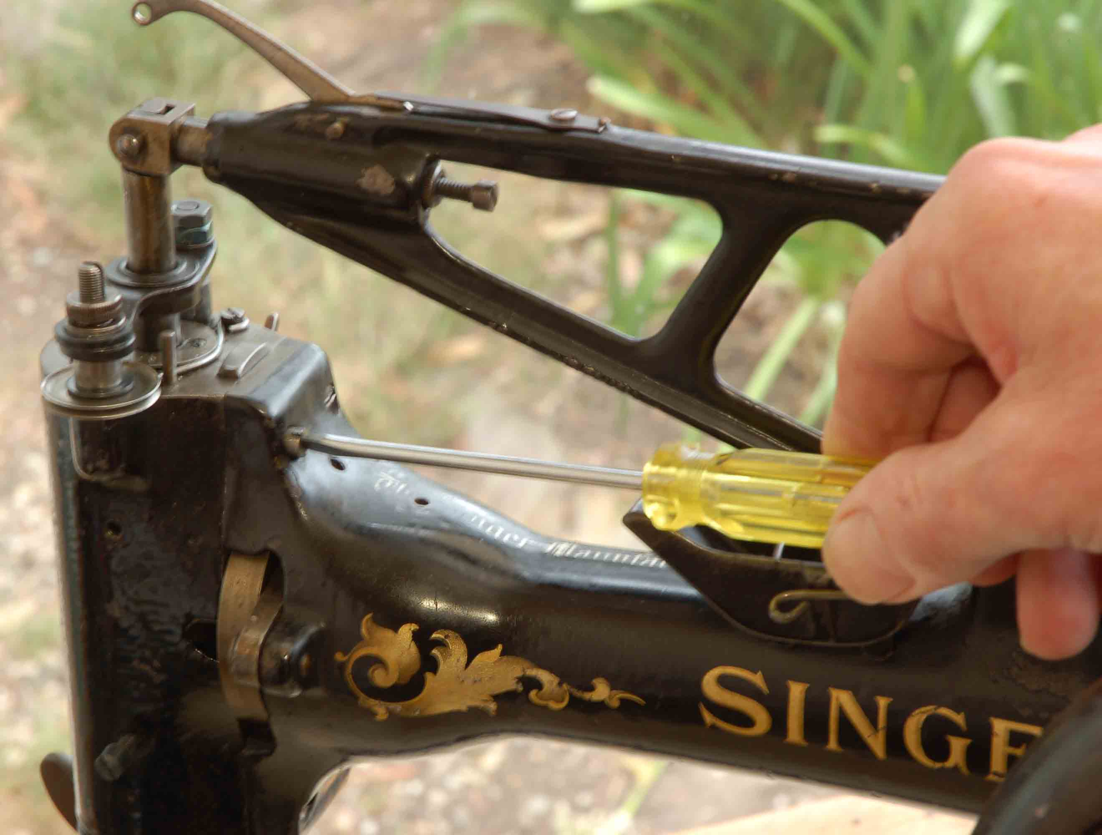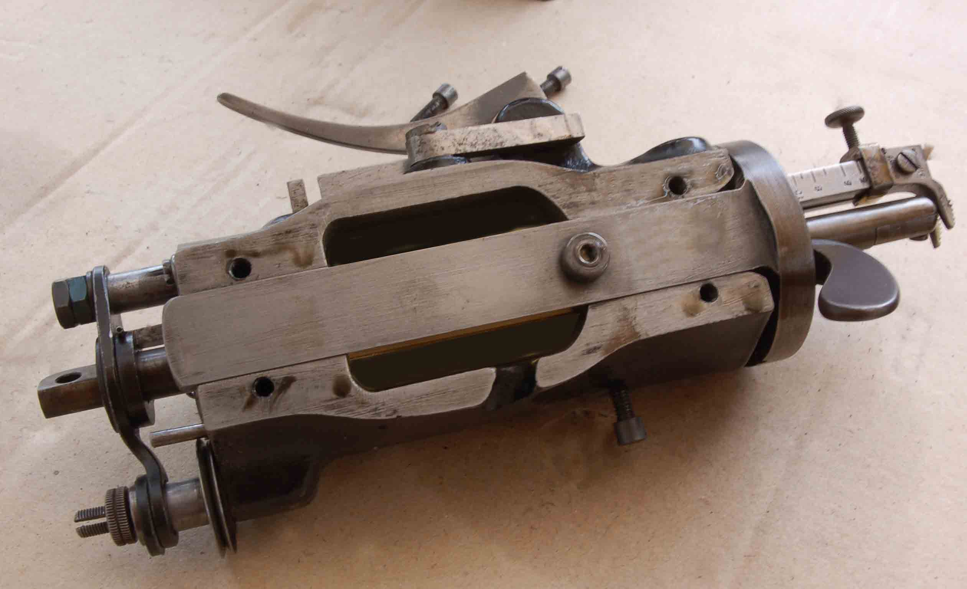

Removing the HEAD fixing screws. Complete HEAD, removed.

BACK TO THE DRAWING BOARD

My first task was to measure up, and make side view drawings of the parts that controlled the number of stitches per inch. Another problem was part No. 8565. It basically consists of a vertical rod with a “figure of eight” plate, riveted to the top. For simplicity, I’ll call this part FOOT LIFT BAR ASSY.

FOOT LIFT BAR

The foot bar lifter, when raised, lifts this part and takes tension off the “THREAD TENSION DISKS”. This was not happening, and was the first thing I fixed.

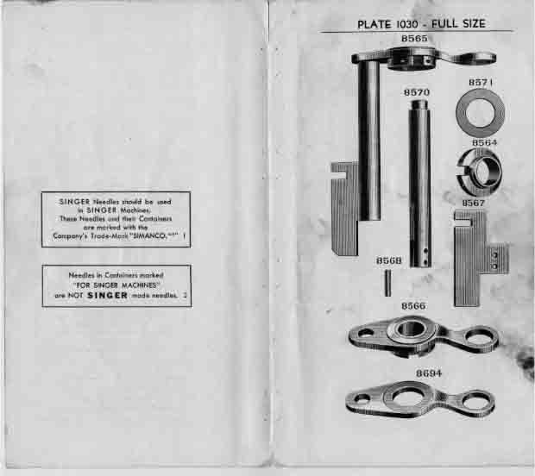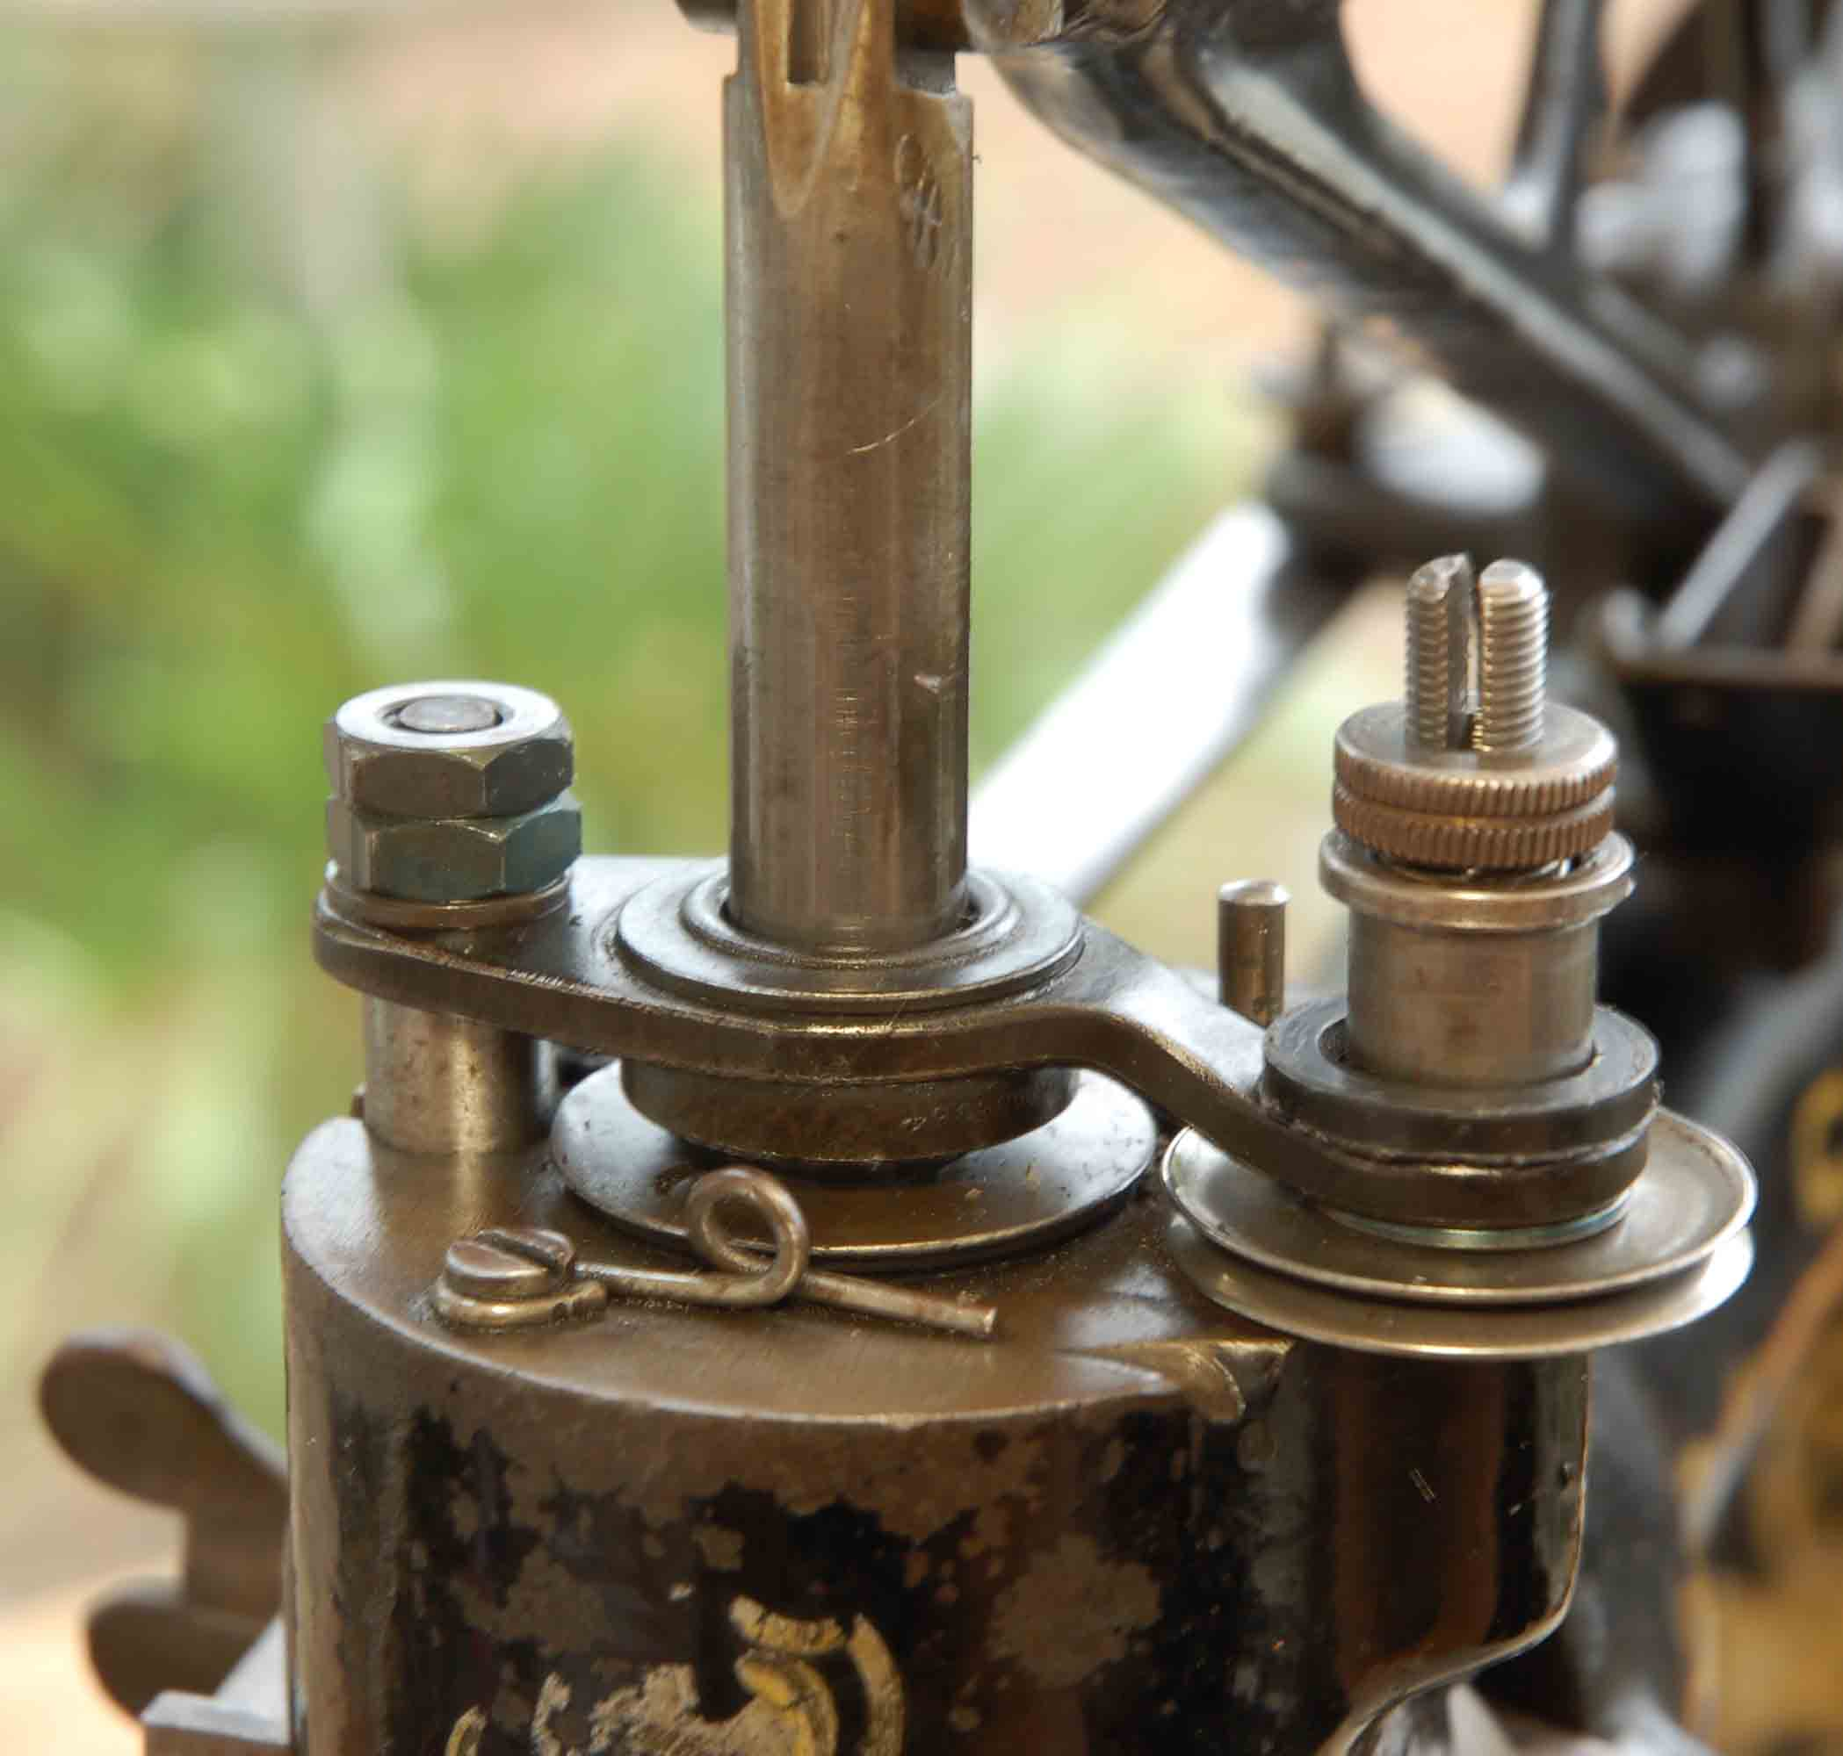

Original FOOT LIFT BAR assy and separate parts. FOOT LIFT BAR modified with locknuts on top.

Attempts to re-peen the top of the FOOT LIFT BAR failed, leaving me little choice. After carefully grinding away the peening, I removed the GUIDE PLATE, and put the part up in a lathe.
With the end drilled and tapped, I made up a stud from an old bolt, and locked it in.
It was reassembled with a plain black washer, and a couple of black locknuts. Better than new!

Below is a drawing of the modifications.
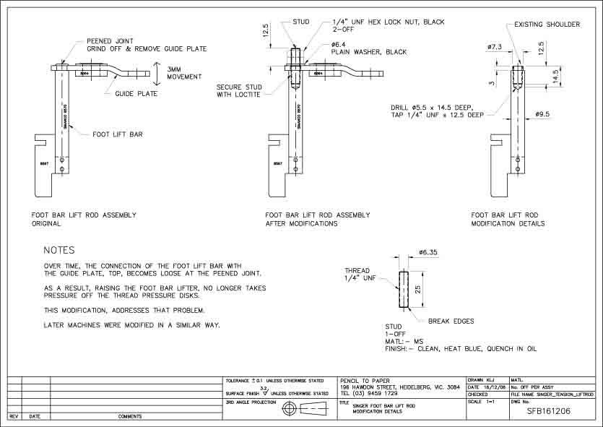

My apologies for the poor quality of the drawing, all lost in the translation from AutoCAD, to PDF, to jpeg, then Word.

WHERE’S WEAR AND WHAT’S WORN

Having drawn up the FEED MOTION BELL CRANK LEVER, and it’s interaction with the FEED MOTION RING SLIDE BAR, I now had a pretty good idea of it’s operation, and the effects of wear.

With two screws removed in the underside of the head casting, it was a simple matter of lifting out the FEED MOTION BELL CRANK LEVER and the REVOLVING BUSH HANDLE assembly.

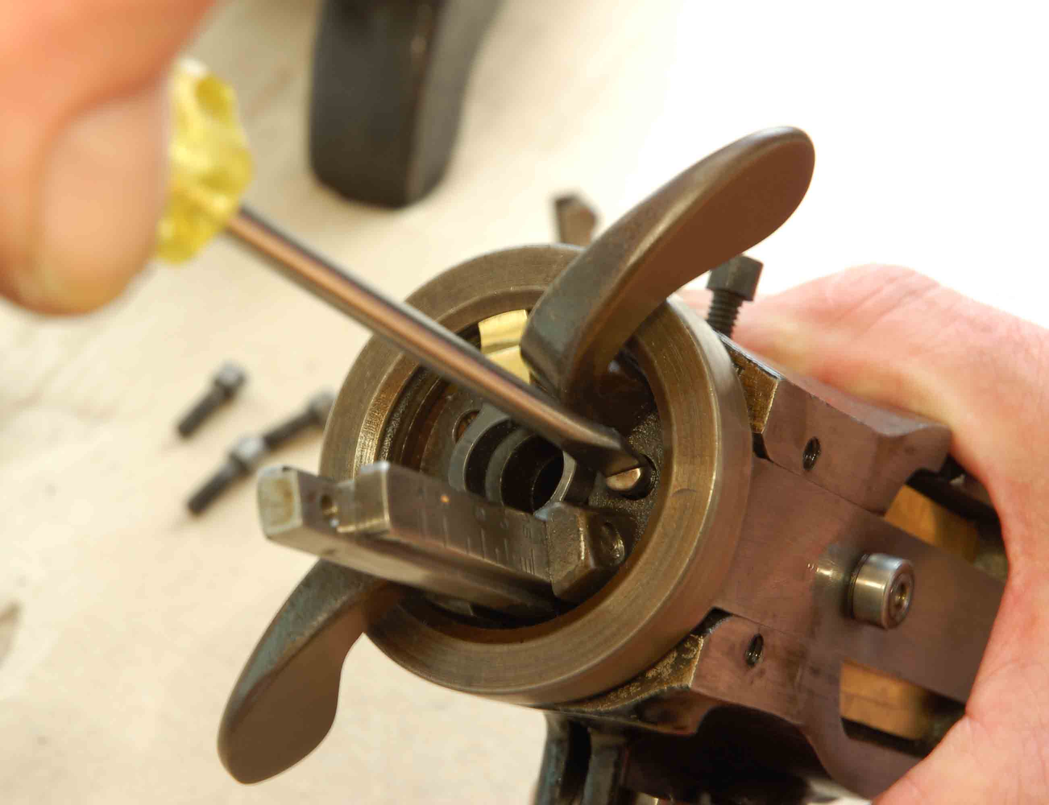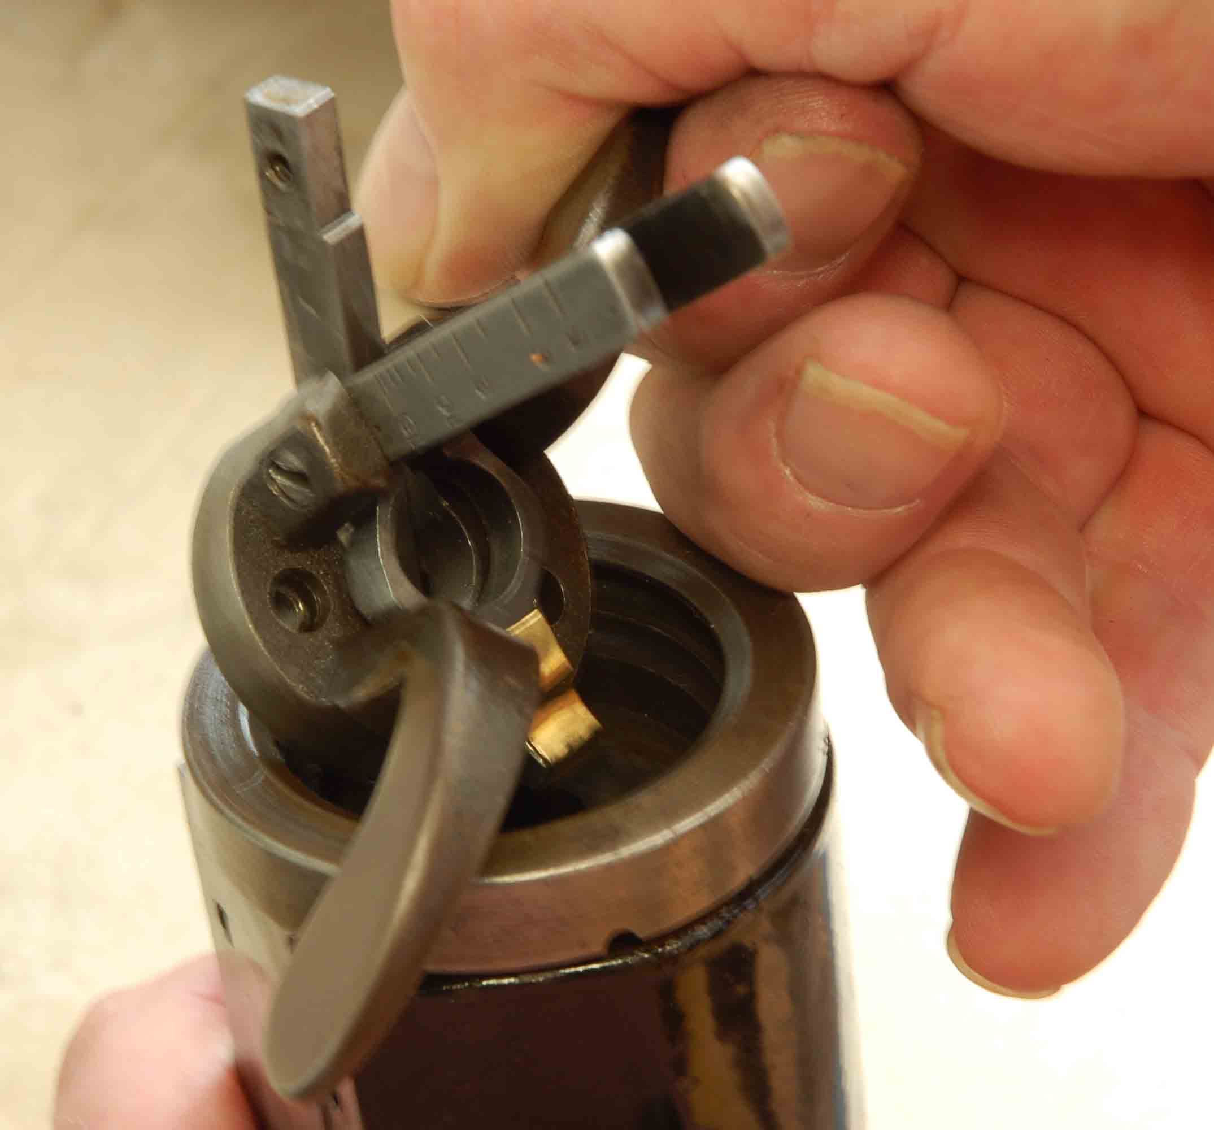

Installing screws in underside of HEAD casting. Replacing HEAD REVOLVING BUSH HANDLE
and FEED MOTION BELL CRANK LEVER assy.

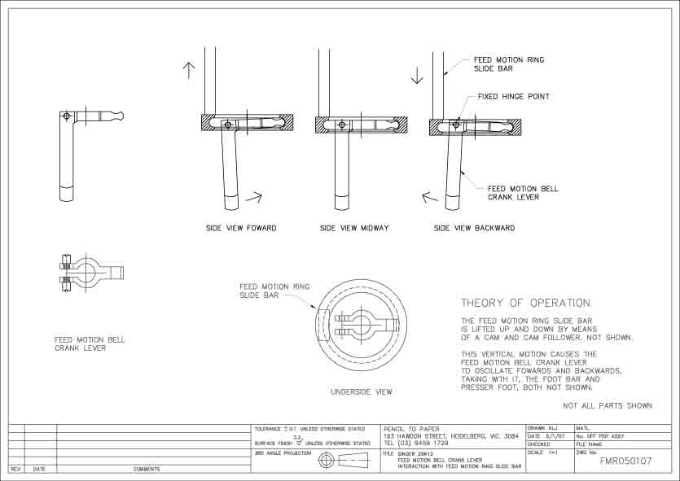

The above drawing shows the interaction of the FEED MOTION RING SLIDE BAR and the
FEED MOTION BELL CRANK LEVER.

THEORY OF OPERATION

The FEED MOTION RING SLIDE BAR, is driven up and down by means of a cam, and cam follower, located inside the head of the machine. This vertical motion causes the FEED MOTION BELL CRANK LEVER, to oscillate forwards and backwards, taking with it, the
FOOT BAR, and PRESSER FOOT.

Part 8559, FEED MOTION BELL CRANK LEVER shown below, had a worn lobe on the end.
Instead of being rounded, it was worn down to a chisel point. Attempts to build the lobe up with molten brass and a butane torch, failed despite proper cleaning and the application of flux.
All I successfully did was turn this part black and cover it in scale. Took hours to polish it back to it’s original condition.
What I needed was a non destructive, reversible fix, and decided to make a shim brass end cap that would just slide on. By trial and error, I was able to determine 0.1mm thick brass would compensate for the wear. Laying a paper template over the brass, it was fairly simple to cut out with scissors
and a Stanley knife. Using a timber former the same size as the lever, I finished up soft soldering each side to keep it together. Timber was used so as not to extract heat out of the brass.
With the shim brass end cap in place, I gently squeezed the top and bottom together to roughly conform to the shape of the lever. The result is a part as good as new!

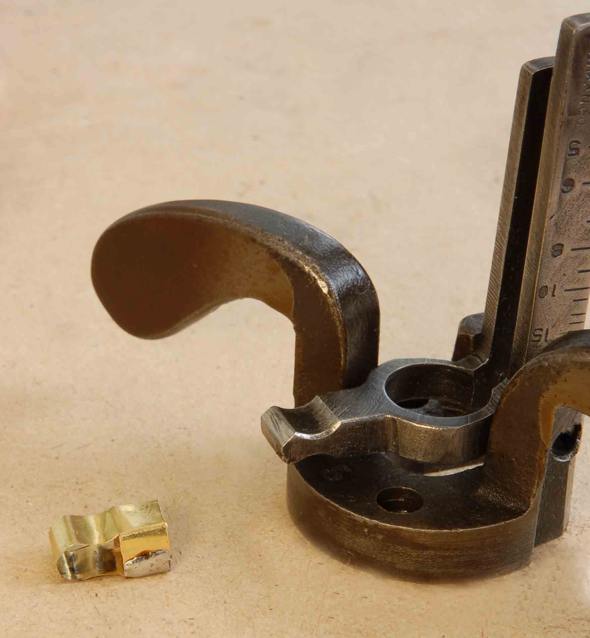

Worn FEED MOTION BELL CRANK LEVER, ready for new shim.

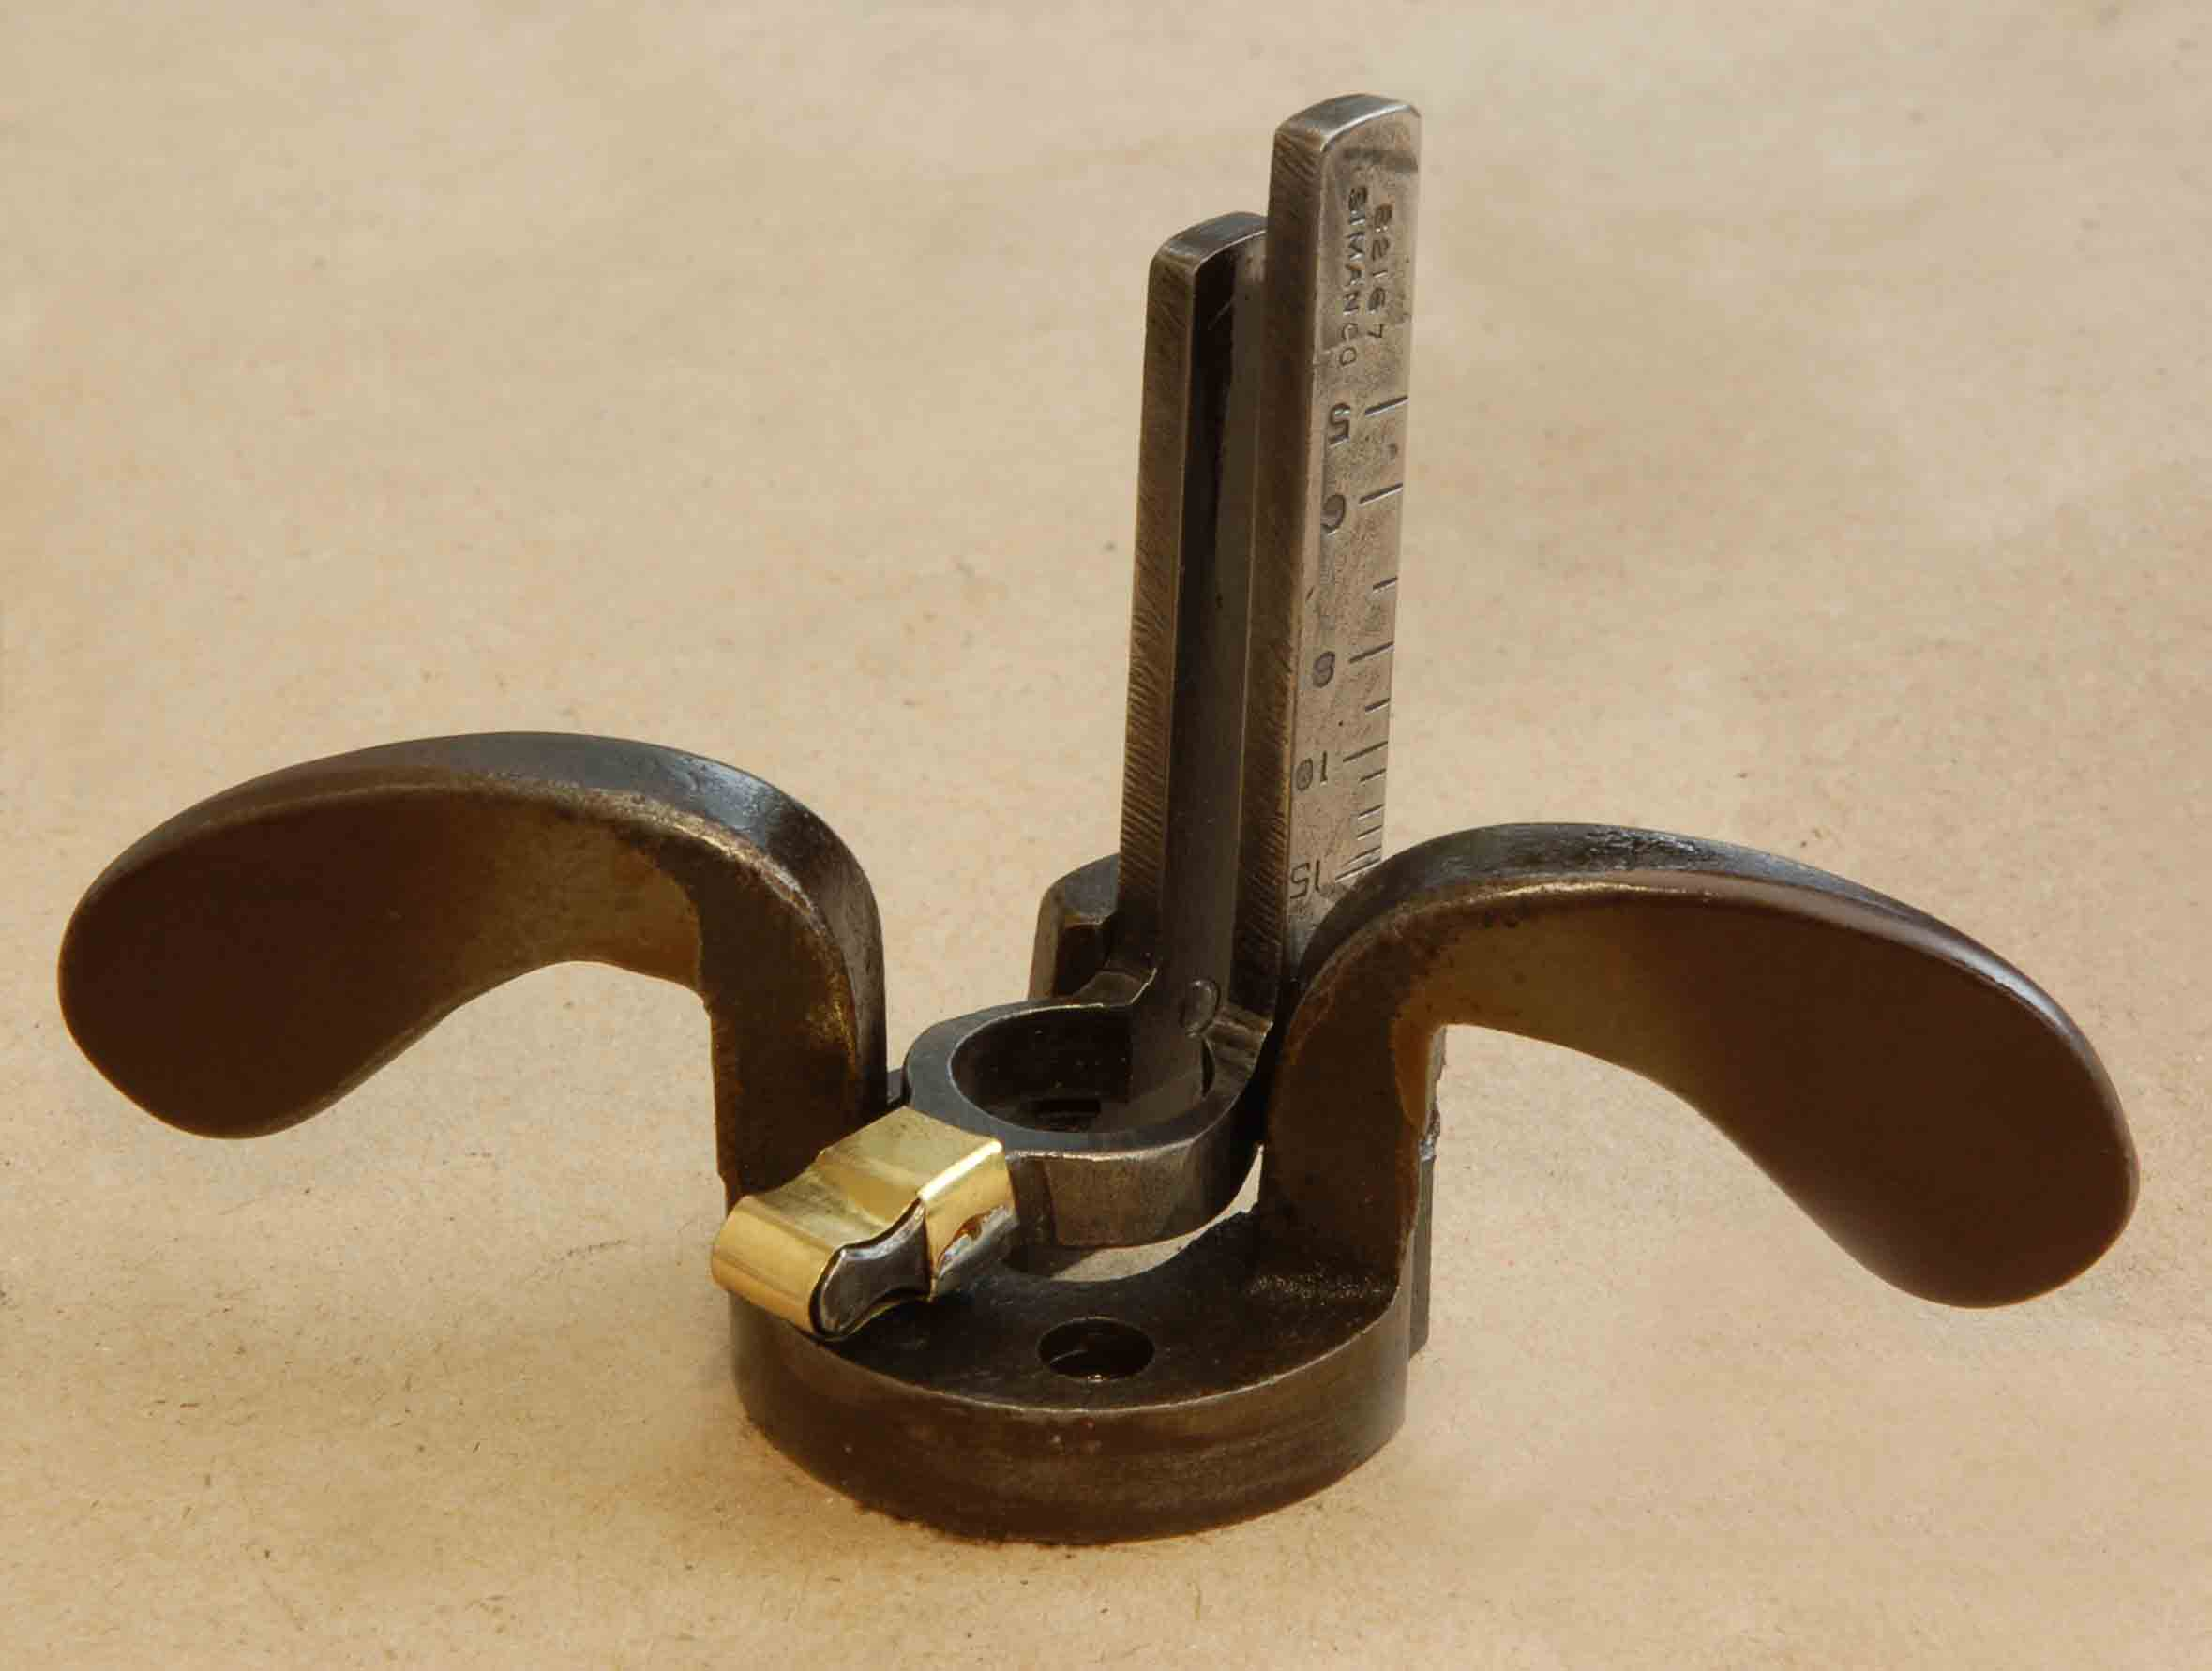

FEED MOTION BELL CRANK LEVER with new shim brass end cap in place.

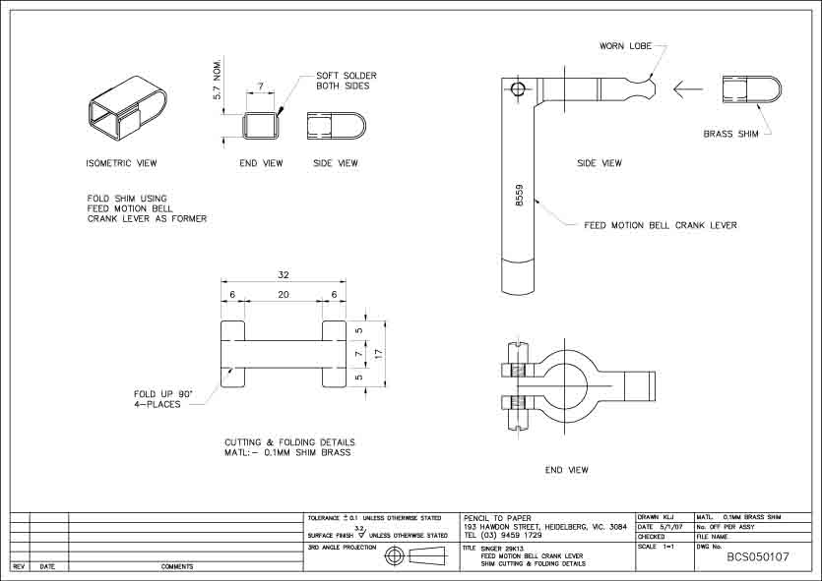

Drawing above shows the shim brass end cap. The blank was folded using the lever as a former.

STITCH REGULATOR

Wrapped around the BELL CRANK LEVER, is clamped the STITCH REGULATOR. If this part is slid down as far as it will go, the maximum stitch length will be achieved, conversely, if slid up, the stitch distance decreases.

WHY IS THIS SO?

Simple really, the BELL CRANK LEVER travels further at the bottom, than it does at the top.

The thickness of material being sewn, also determines the stitch length. The thicker the material, the shorter the stitch length. The higher up the presser foot finishes, the less distance it travels.

Confused, join the club?

The STITCH REGULATOR was badly worn inside where the FOOT BAR had been rubbing and had to be repaired.

With a 4mm wide strip of 0.05mm shim brass, I wrapped this in through and around the body of the STITCH REGULATOR, effectively filling in the worn groove.

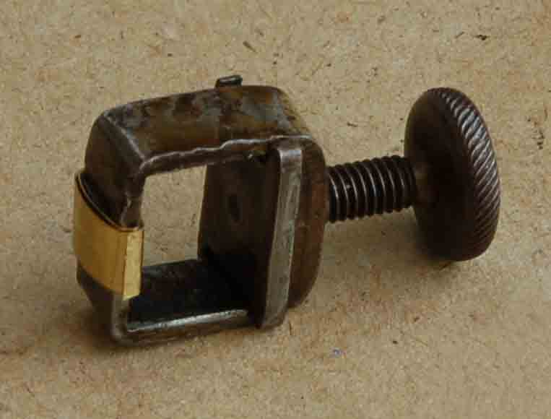

STITCH REGULATOR repaired.

SHIM BRASS

Shim brass is easy to find, I purchased mine from a local company in West Heidelberg, Melbourne.

“I would like some shim brass 0.05mm thick, say 150x150mm”. The man behind the jump, raised his eyebrows, and disappeared, I followed him out into the factory.

Scrounging through the shelves, he finally found a roll, about six inches in diameter.
“The minimum order is $10”. After a quick calculation, I had to buy a metre.

Ah well, at least I’ve got the next 100 machines covered.

ICYPOLE STICK IN A 44 GALLON DRUM

In the head casting, is a machined groove that locates the FEED MOTION RING SLIDE BAR.

There was at least 0.1mm slop between these parts, so it was next on the agenda.

0.1mm, or 0.05mm a side, doesn’t sound much, but enough to effect proper operation. More shim brass came to the rescue. Again, I laid a paper template over some 0.05mm shim, and cut the part out with scissors. Folded around the SLIDE BAR, it fitted perfectly into the machined groove.
The wings on either side of this shim, prevent it from moving up or down.
The head casting has relief to accommodate this.

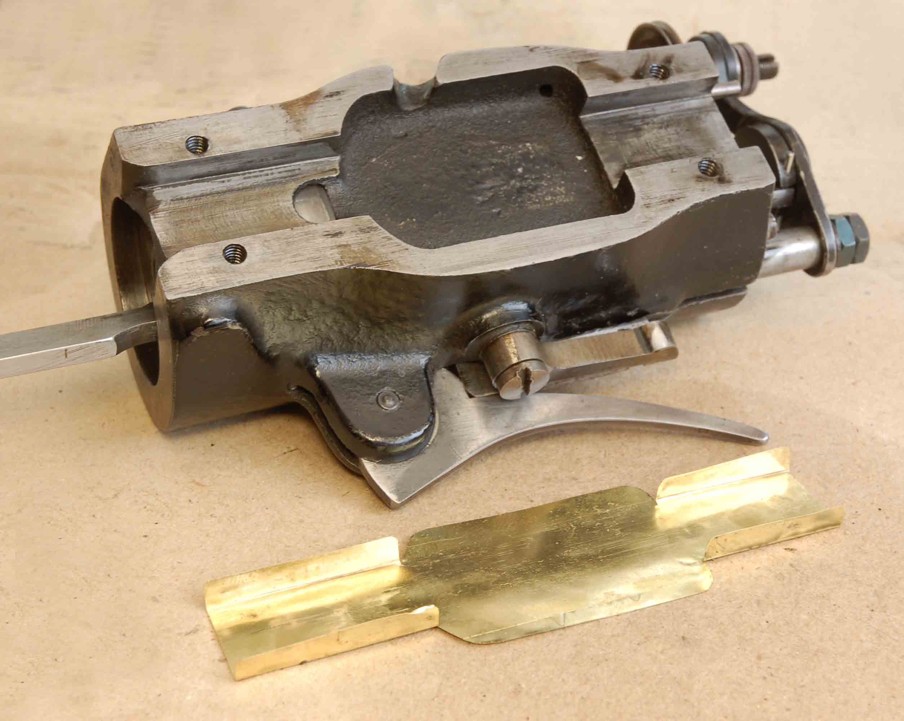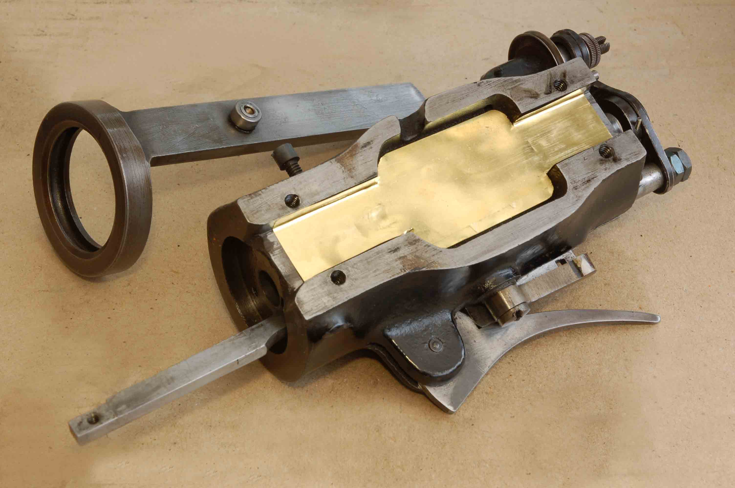

HEAD casting showing new shim brass sleeve. FEED MOTION RING SLIDE BAR and HEAD casting with new . shim in place.
At the top of the foot bar, is a small hole through which a pin is fitted to hold it in place. This hole had worn and was repaired with a strip of shim brass wound up like a clock spring to form a bush.

In my case, the pin had been lost and replaced with a crude nail. A quick fix was a 1/16” dia. x 1/2” long Sellok pin, perfect!

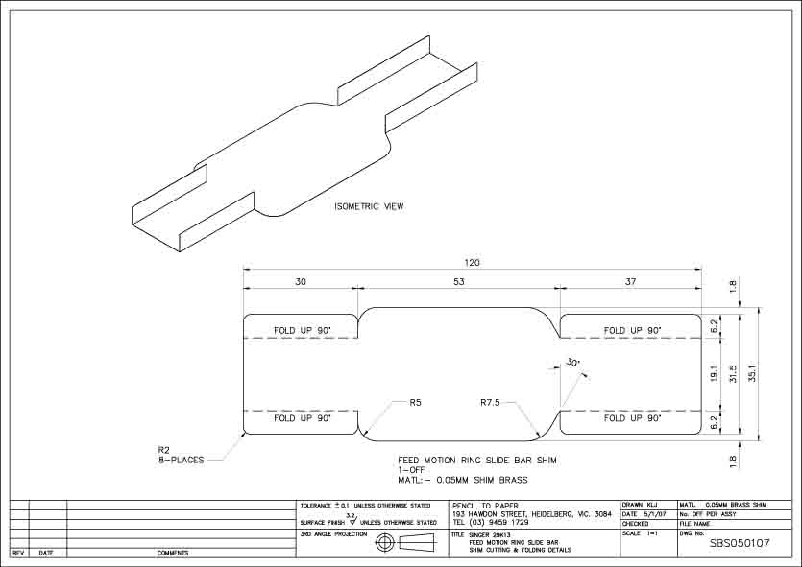

Drawing above shows the shim brass sleeve. The blank was folded using the slide bar as a former.

All parts were oiled, and carefully reassembled, the result being a machine that sews like brand new.

No more slop, no wear, and a maximum stitch length of nearly 4mm in two layers of 3mm leather.

I’m more than happy with that!

If you would like A4 size PDF copies of the drawings, send me a PM with your email address.

A parts list and drawings can be found on the www.singerco.com web site, select Singer parts and Industrial products, on the next page, select Replacement Part charts and scroll down to 29-4.
These parts are very similar to model 29K13.

What’s next, maybe I need a bit of shimming?

Ken Jerrems,
Australia

